**Assignment 4:**

**Implement A* Algorithm for an Application**

**Problem Statement**

The objective of this assignment is to implement the A* search algorithm for a pathfinding application. This involves developing a method to find the most efficient path from a starting point to a goal while considering various obstacles and costs associated with movement.

**Objectives**

* Understand the principles of heuristic search.
* Implement the A* algorithm to find the optimal path in a grid or graph-based environment.

**Theory**

**What is the A* Algorithm?**

A* is a widely used heuristic search algorithm that combines aspects of both Dijkstra's algorithm and Greedy Best-First Search. It efficiently finds the least-cost path from a start node to a goal node by considering both the actual cost to reach a node and an estimated cost to reach the goal.

**Methodology**

1. **Define a Heuristic Function**:
   * The heuristic function h(n)h(n)h(n) estimates the cost from the current node nnn to the goal node. Common heuristics for grid-based pathfinding include:
     + **Manhattan Distance**: h(n)=∣x1−x2∣+∣y1−y2∣h(n) = |x_1 - x_2| + |y_1 - y_2|h(n)=∣x1​−x2​∣+∣y1​−y2​∣ (suitable for grid movements where diagonal moves are not allowed).
     + **Euclidean Distance**: h(n)=(x1−x2)2+(y1−y2)2h(n) = \sqrt{(x_1 - x_2)^2 + (y_1 - y_2)^2}h(n)=(x1​−x2​)2+(y1​−y2​)2​ (suitable for grid movements that allow diagonal moves).
2. **Explore Nodes Based on Cost**:
   * Each node in the search space maintains two costs:
     + g(n)g(n)g(n): The cost to reach the node from the start node.
     + f(n)=g(n)+h(n)f(n) = g(n) + h(n)f(n)=g(n)+h(n): The total estimated cost of the cheapest solution through node nnn.
3. **Continue Until the Goal is Reached**:
   * Initialize the open list with the start node and the closed list as empty.
   * While there are nodes to explore:
     + Extract the node with the lowest f(n)f(n)f(n) from the open list.
     + If this node is the goal node, backtrack to find the path.
     + Otherwise, generate its successors, calculate their costs, and update their lists accordingly.
     + Move the current node to the closed list to prevent re-exploration.

**Working Principle / Algorithm**

Here’s a simple outline of the A* algorithm:

1. **Initialize the Open and Closed Lists**:
   * Start with the initial node, add it to the open list.
2. **While the Open List is Not Empty**:
   * Choose the node with the lowest f(n)f(n)f(n) from the open list.
   * If the chosen node is the goal, reconstruct the path and terminate.
   * Generate each of its neighboring nodes.
     + Calculate g(n)g(n)g(n) for each neighbor.
     + If a neighbor is in the closed list and the new path is better, update its cost.
     + If a neighbor is not in either list, add it to the open list.
3. **Path Reconstruction**:
   * Trace back from the goal node to the start node using parent pointers or a path list.

**Advantages**

* **Optimality**: A* guarantees the shortest path if the heuristic used is admissible (i.e., it never overestimates the cost to reach the goal).
* **Flexibility**: A* can be adapted with different heuristics to fit various types of pathfinding problems.

**Disadvantages / Limitations**

* **Memory Usage**: A* can be memory-intensive for large search spaces, as it stores all generated nodes in the open list.
* **Performance**: The performance can degrade significantly if the heuristic is not well-designed or if the search space is too large.

**Diagram**

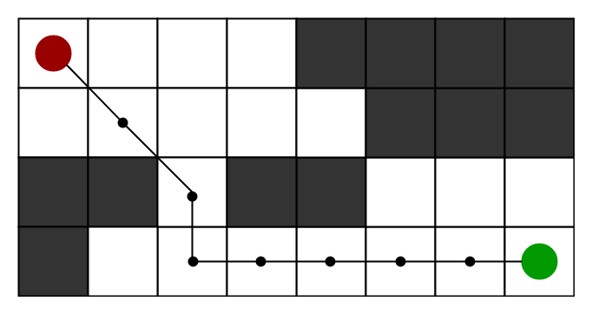

**Conclusion**

The A* algorithm is an efficient search method that balances exploration of the search space with heuristic estimation to find optimal paths. Its flexibility and optimality make it a popular choice for various applications, including robotics, game development, and navigation systems.